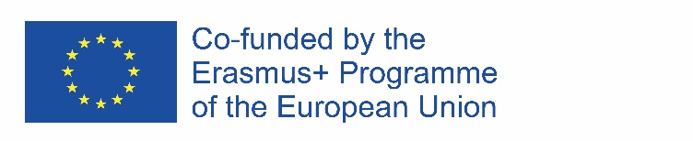 | 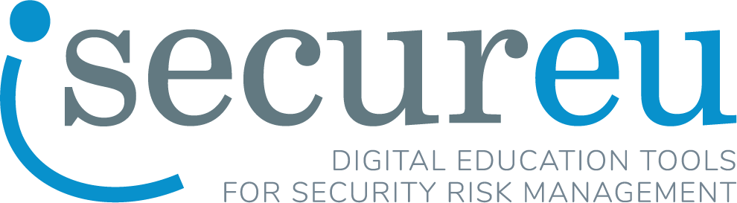
ERASMUS+ Strategic partnership “Digital education tools for security risk management”
Project number: 2021-1-LV01-KA220-HED-000023056

SUMMER COURSE “SECURITY RISK MANAGEMENT”
07.08-18.08.2023, RIGA, LATVIA
(arrival date 6.08.2023, departure date 19.08.2023)

APPLICATION FORM

Name

Surname

Gender
Citizenship

Date of birth

Home University

Study programme, level (bachelor or master), study year
E-mail and contact phone

Please explain your motivation to participate in Intensive course

By sending this application form I certify that the information provided is correct. I agree that my personal data (name, surname, personal identity number, contact information, gender, information about home University and study programme) will be processed by Turiba University and will be stored for a period of time requested by the ERASMUS+ project financing authority. As well as applying for the courses, I agree that Intensive Courses will be photographed and filmed and audio-visual materials will be used for publicity reasons in websites, social networks or printed media.

